Problem Statement:
Electronic devices require a stable voltage supply for proper operation. However, input voltages often fluctuate due to variations in the power source or load conditions, which can damage sensitive components. The challenge is to design a simple, cost-effective circuit that can maintain a constant voltage despite these fluctuations. This project investigates the use of a Zener diode in reverse bias to provide voltage regulation and protect electronic circuits from unstable voltage.
Abstract:
A Zener diode is a special type of diode designed to operate in reverse bias, allowing current to flow when a specific breakdown voltage is reached. Unlike regular diodes, it can safely operate in reverse bias without damage. This property makes it ideal for voltage regulation and providing a stable reference voltage in electronic circuits.
In this project, the reverse bias characteristics of a Zener diode are studied by applying a varying input voltage and measuring the voltage across the diode. A series resistor is used to limit current, and different load resistances are tested to observe the diode’s voltage regulation capability. The project demonstrates how the Zener voltage remains almost constant even when the input voltage or load changes.
The results show that the Zener diode effectively stabilizes the voltage, making it useful for low-power electronic devices that require consistent voltage supply. This study highlights its importance in protecting sensitive components from voltage fluctuations and in applications such as voltage regulators, power supplies, and reference circuits.

Introduction:
A Zener diode is a special type of semiconductor diode designed to allow current to flow in the reverse direction when a specific voltage, called the Zener voltage, is reached. Unlike ordinary diodes, which are damaged if reverse voltage exceeds their limit, a Zener diode is specifically manufactured to operate safely in the reverse breakdown region. This makes it a crucial component in voltage regulation and protection circuits.
The primary function of a Zener diode is to maintain a constant voltage across a load, even when the input voltage or load current varies. This property is widely used in power supplies, voltage references, surge protection, and electronic circuits where stable voltage is critical. When connected in reverse bias with a series resistor, the Zener diode allows excess current to flow through it, keeping the voltage across the load nearly constant at the Zener voltage.
This project focuses on studying the reverse bias characteristics of a Zener diode. By applying different input voltages and varying load resistances, we can observe how the Zener diode stabilizes the output voltage. The study not only helps in understanding the fundamental behavior of Zener diodes but also demonstrates its practical applications in electronic circuits as a simple and cost-effective voltage regulator.
Objective Definition:
The main objective of this project is to study the characteristics of a Zener diode in reverse bias and demonstrate its practical application in voltage regulation circuits. Zener diodes are widely used in electronics to provide a stable reference voltage, protect circuits from voltage fluctuations, and maintain constant voltage across sensitive components. Understanding their behavior is crucial for designing reliable electronic devices.
The project specifically aims to:
- Analyze Reverse Bias Characteristics:
  - Study how the Zener diode behaves when a voltage higher than its rated Zener voltage is applied in reverse bias.
  - Identify the breakdown region and understand the relationship between current and voltage in this region.
- Verify Zener Voltage:
  - Measure the voltage at which the diode starts conducting in reverse (Zener voltage).
  - Compare the experimental results with the manufacturer’s specifications to understand tolerances and real-world behavior.
- Demonstrate Voltage Regulation:
  - Build a simple circuit using a series resistor and Zener diode to maintain a nearly constant output voltage.
  - Observe how the voltage remains stable under variations in input supply voltage and load resistance.
- Understand Practical Applications:
  - Learn how Zener diodes are used in power supply circuits, voltage reference circuits, and protection circuits.
  - Explore the advantages and limitations of using Zener diodes for low-power voltage regulation compared to other methods.
By achieving these objectives, the project provides both theoretical understanding and practical insight into the use of Zener diodes in electronic circuits. It demonstrates a simple yet effective way to control voltage, which is essential in almost all electronic systems.
Feasibility & Relevance:
Feasibility:
The project is highly feasible for an undergraduate ECE mini project because it involves simple components and basic laboratory equipment:
- Components like Zener diodes, resistors, DC power supplies, voltmeters, and ammeters are readily available and inexpensive.
- The experiment can be conducted on a breadboard or simulation software like TINA-TI or Multisim, making it easy to test without complex setups.
- The calculations and analysis involve basic electronics concepts such as Ohm’s law, voltage-current relationships, and diode characteristics, which are within the grasp of an undergraduate student.
- The project does not require high voltages or hazardous equipment, making it safe to implement in a standard lab environment.
Relevance:
The project is highly relevant to the field of Electronics and Communication Engineering for the following reasons:
- Most electronic devices require stable and regulated voltage supplies for proper functioning; fluctuations can damage sensitive components.
- Zener diodes are widely used in voltage regulators, power supplies, and reference circuits, which are fundamental concepts in electronics.
- Understanding Zener diode behavior in reverse bias helps students bridge theory and practice, showing how semiconductors are applied in real-world circuits.
- The study reinforces the concept of diode characteristics, voltage regulation, and circuit protection, which are core topics in electronics coursework.
- It also serves as a foundation for more advanced topics such as DC-DC converters, voltage reference ICs, and precision regulation circuits.
Overall, this mini project is both practically feasible and academically relevant, providing hands-on experience with a widely used electronic component while enhancing understanding of essential concepts in electronics.
Circuit Diagram:
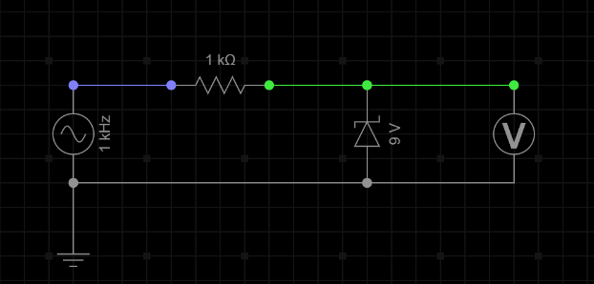
Simulation Results:
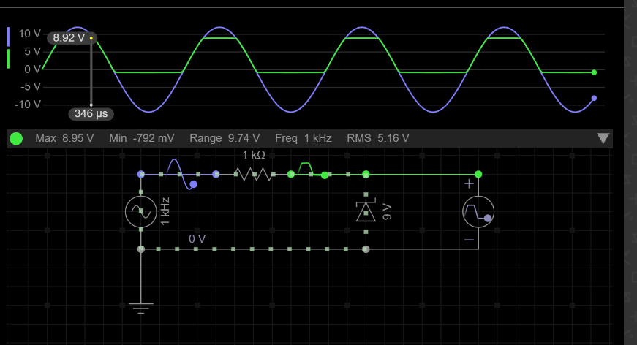
GitHub Link:

